**CODE EXPLAINATION STEP BY STEP**

**Task : Make a Guess a Number With the help of JAVA:**

**Section 1: Initialization and Setup:**



Imports the necessary classes for generating random numbers and reading user input.



Defines the Main class, the entry point for the program.



Creates objects for reading user input (scanner) and generating random numbers (rand).

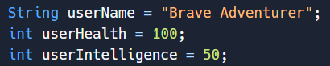

Initializes variables for the user's character name, health, and intelligence.



Defines an array containing the types of treasures available in the game.

**Section 2: Welcome Message and Secret Number Generation:**



Displays a welcome message and information about the user's character.



**Section 3: Gameplay Loop and User Input:**

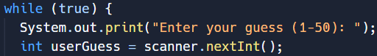

Starts an infinite loop for the gameplay. Prompts the user to enter a guess for the secret number and reads the input.

**Section 4: Checking the User's Guess:**

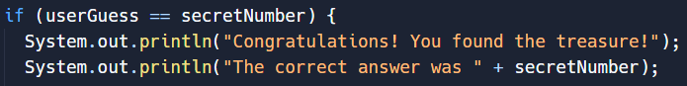

Checks if the user's guess matches the secret number. And Displays a success message when the user guesses the correct number.

**Section 5: Displaying Treasure Chest Contents and Choosing Items:**

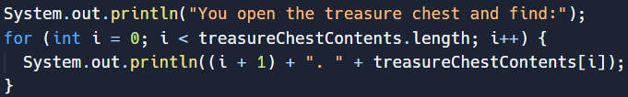

Displays the contents of the treasure chest and prompts the user to choose an item.

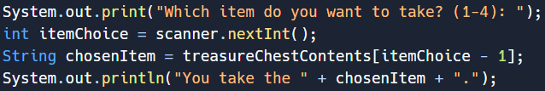

Reads the user's choice of treasure item and displays the chosen item.

**Section 6: Applying Effects of Chosen Item:**

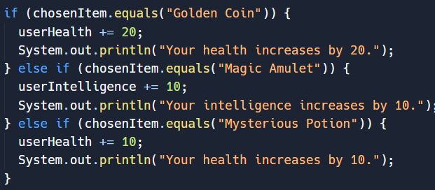

Applies the effects of the chosen item on the user's health or intelligence.

**Section 7: Displaying Updated Stats and Breaking the Loop:**



Displays the updated health and intelligence stats of the user and breaks the loop, ending the game.

**Section 8: Handling Incorrect Guesses:**

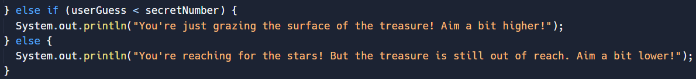

Provides feedback to the user based on their guess, indicating whether it is too low or too high.

**Section 9: Quitting the Game:**

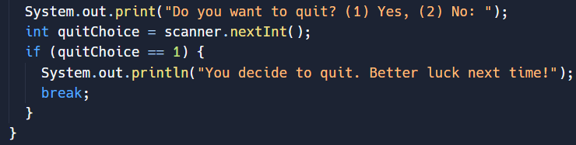

Asks the user if they want to quit the game and breaks the loop if the user chooses to quit.

**Section 10: Farewell Message:**

